MY CHURCH RECORDS
Guidance for Church Teams on Engaging with “Family History Tourists”
Purpose of this guide: The MyChurchRecords initiative aims to connect people with their local church through their interest in family history and the unique content of church register records. As an accompaniment to that, we’re offering this guide to church teams to help them as they welcome an increasing number of family history enquiries and visitors. This is not meant to be a prescriptive or complete list, but rather a set of suggestions to help you get started using this increasingly important mission dimension.

Why should I care about church history?

THERE ARE INCREASING NUMBERS OF FAMILY RESEARCH TOURISTS CONTACTING AND VISITING CHURCHES
There is a huge, growing public interest in tracing family history, highlighted by TV shows such as ‘Who do you think you are?’ This has been massively streamlined by the Internet, with major commercial companies such as Ancestry offering millions of searchable records online
Within the UK, Church of England records are the single most valuable source for this information. Church birth, marriage and funeral registers provide exactly the names, dates and places that researchers need. While the UK government has recorded births, marriages and deaths for around 150 years, the Church of England has captured this info since the order of 1538!
MyChurchRecords is a national initiative using the Church’s historic register archives to drive church growth.

THESE CAN LEAD TO REAL NEW CHURCHGOERS
From discussion with local vicars in various dioceses, it’s clear that they regularly receive requests to look up a family name or otherwise explore family history in the church records or churchyard. They often relate stories of how these families subsequently got involved in the church:

Real Examples of how visits lead to church growth
- As part of national Heritage weekend, one local church posted a series of 6 simple signs inviting visitors to read a little of the church history. This attracted several hundred visitors to explore the churchyard further, and resulted in a number of new attendees to following Sunday services
- At St John’s, a non-Christian with an interest in history started documenting the churchyard
-> Now Sue is committed Christian, with her family also engaged in Church activity
- Local History Society of 50 people got involved documenting local church history
-> 5 have started attending local church regularly
- One parish cites that, over the last 18 months, 20 people have got interested and developed relationship with their church on basis of interest in church’s place in local history
- After being brought to her grandmother’s old family house by a small parish vicar, one lady left in tears and vowed to rebuild her family’s hundreds of year old connection with that church

IT’S IMPORTANT THAT WE ACT ON THESE VISITORS

Bob Jackson, recently retired as the Archdeacon of Walsall and a specialist in church growth, argues that cultivating effective welcome is one of the most significant and important things our churches can do to enable fruitful growth. He writes:
“It is still Jesus’ own job to draw all people to himself (Matthew 16.18) and he is still doing his job. The main problem and opportunity for the growth of the Church today is how well we who are already in the Church welcome the people whom God is sending us to join the Church. It is as surprisingly basic and simple as that.”
What impression does a church building make on such modern non-churchgoing people? The words ‘we aim to change tourists into pilgrims’ trip lightly off many lips. Realism says that for many tourists this is a touch ambitious; a 5-10 minute visit isn’t going to achieve that transformation. But there are ways we can and should disturb existing prejudices and spark some imagination and interest in what the church is about.
At the very least, every church could try to convey three messages to its’ visitors:
- We are glad you are here, this place is for you
- This is not just a beautiful old building, it is a sacred space. You may simply feel that it is somehow ‘special’
- This church is alive, loved and used regularly by people who follow the way of Christ
As Revd Eileen McLean put it after her study of church visitors,
“In a secular age it is a real challenge to present the truths of the Christian faith using comprehensible, attractive and gentle language and imagery. It is right that we should seek to impress and inspire visitors with the fascinating history and beautiful architecture of our churches, but is also important that we should seek to engage them in the faith for which those churches were built.”

THIS GUIDE OFFERS SIMPLE ADVICE TO DO THAT
In this guide, we provide some simple thoughts on how a church might effectively engage with
We recognize that all our clergy and congregations are very busy, so have divided this into three convenient sections for ease of use:

1) Quick Wins for Church Teams
2) Further Steps
3) Helpful Templates

- Quick Wins for Church Teams

How does our church welcome visitors?
Walk around and ask yourself the basic questions below
Ask a non-churchgoing friend to act as a ‘mystery shopper’ by walking around and jotting down notes on these questions. You might be surprised how differently they respond!

Church Accessibility
- Are opening hours clear on the website and church signs?
- How easy is it to get in? is the entrance obvious and accessible, or signposted?
- Is it clear when the church is open and welcoming visitors?
- Are light switches clear, should we add simple signs indicating their position and operation?
- Once inside, is it easy, unobstructed to walk around?
- Are major areas of the church signposted?
- Do we have a keyholder rota, listed on a sign for visitors to gain access out of open hours?

ChurchYard
- Is it open to the public? Is the entrance obvious or signposted?
- How easy to get around – do we need to tidy or clear paths or grass? Perhaps hold a ‘cleanup day’ or invite the local school to help
- How well are the gravestones maintained – are most legible? Send a simple reminder to each family that they are responsible for family graves, encourage regular maintenance

Signs
- What signs are at the church gate, in the church entrance, in the church yard, at the door?
- Do the signs include basic information on service times and contacts
- Do they express a clear welcoming tone?

How do you answer family history enquiries?
You may well receive emails or in-person requests from people interested to find out more about their family’s history in your parish.

- Have a walk around your churchyard, make a note of the family names that appear frequently or prominently
- Talk to local buffs about the history of the church in the parish
- Your historic registers are likely stored at the local county archive. So you may refer the enquiry there for a search of those records
- Any communication about family history is an opportunity to connect with the researcher. Invite them along to visit the churchyard
- If visitors do arrive at your church, engage them in conversation about their family and take the opportunity to explain the ethos of your church a little more
- You might even suggest to a new visitor that they maintain a relevant family grave, a good way to build them a bridge back into their historic family church community

CONSIDER THE BASIC EXPERIENCE OF A VISITOR

Welcome Signs

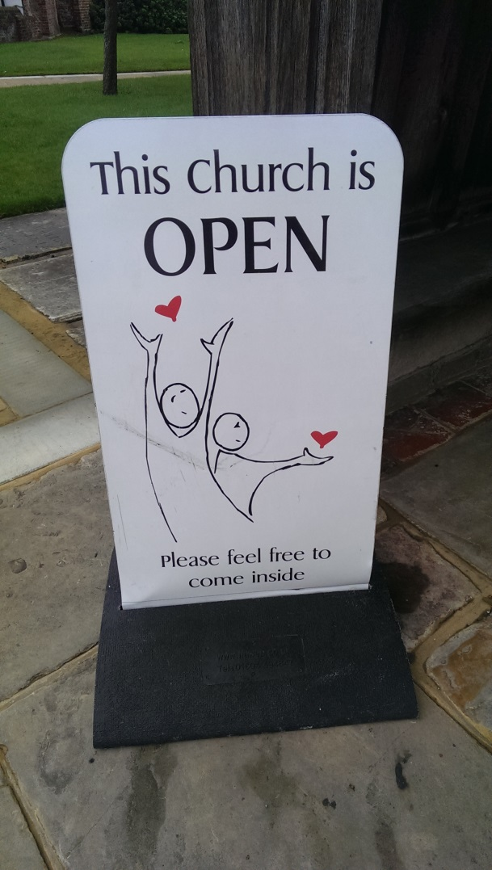

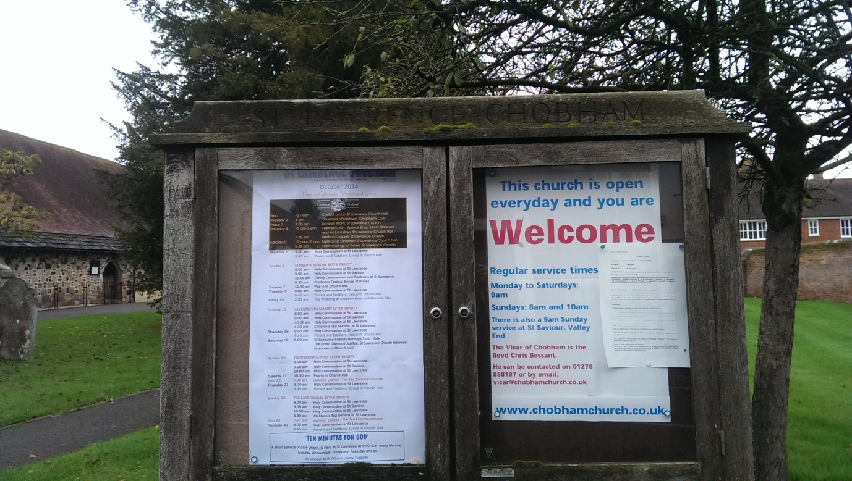
- Further Steps

Identify the right team
Church visitors and family history represent a genuine, growing opportunity for local church growth. So it’s worth taking the time to identify the right person(s) in your church community to take charge of this area, and who might best help them:

- Who should lead this? Probably not the vicar!
  - It’s a perfect topic to delegate to a suitable community member
  - There’s a good chance that your church includes a number of people who are really interested in church or family history. They will be excited and happy to engage with a role leading this sort of initiative, so that is the best option if possible
  - The PCC may also have suggestions and input on the best way to staff this initiative
- Get help! These other groups might be willing to get involved
  - Most parts of the country are covered by a local history society. Their members will be keen to get involved with documenting the church or churchyard history. You can look them up at the Federation of Family History Societies
  - Similarly, local museums may be willing to participate in an effort to better document their local area
  - Often local schools are also keen to get involved in local community projects like this - a group of children can perform useful work as a school project

THIS INITIATIVE PROVIDES MANY OPPORTUNITIES TO BUILD COMMUNITY RELATIONSHIPS AND CHURCH PRESENCE

Build a “History and Tourism Action Plan”
- Make Your Church Say “Welcome!”
  - Invite relevant children’s groups to make some simple, bold Welcome signs
  - Build an ‘active keyholder’ rota so visitors can always get in touch with someone, and the building is open as much as possible
- Document your church history
  - Identify elements that are particularly interesting or significant for history – parts of the church fabric, particular inscriptions, plaques or graves
  - Create a plan of the church building, noting locations of historic items and plaques
  - Create a plan of the churchyard, with index of names on the stones
  - Photograph and transcribe each gravestone and commemorative plaques
- Share the information
  - Create leaflets on the church heritage and history, make available to visitors at an outdoor sign board, foyer or in the church. See the Resource Guide for suggestions
  - Add some of this great information to your church website – section on church history, as well as the photographs and indexed plans of the church and churchyard
  - Offer a link titled “Find out more about Church buildings across the country” that sends visitors to the CofE Heritage Record website
  - Share your new heritage documentation and photos with the team at Church House, Westminster, for inclusion in the Church Heritage Record Julie.patenaude@churchofengland.org
- Prepare to answer email or phone enquiries from family historians
  - Talk to your local county archivist about how the parish registers are stored and how the public can access them. They will be available to search in the archive office, and may also be available online
- Resource Guide

It’s very helpful for visitors if your church is able to offer information in a simple, accessible way. Either on signs and noticeboards, or in the form of takeaway leaflets. Both IN the church and outside in a foyer if possible.
We list here suggestions for the sort of content you might want to consider, and attached to this guide you’ll find some simple suggestions for layout.

- Poster template (include Sections, formats all sorted)
  - Include FMP logo if relevant
  - All the people
  - Names and numbers – history buff on PCC
- Welcome signs
  - Bright, colourful
  - Clear message that the Church is Open!
- Church Heritage Leaflet
  - Short description of Building and its history
  - Map of Churchyard – pointing out famous graves, mention common family names
  - Brief church philosophy
  - Offer people ways to get involved – volunteer to maintain a family grave, join us for a clean-up day, etc
  - Include call to particular services targeting new attenders
- Signposting ‘trail’ around churchyard
  - Guide people on a path through the yard, highlighting interesting or historic graves
  - Include invitation to suitable worship service and/or Bible verses
  - Perhaps for special events like Easter or National Heritage weekend
- Welcome Pack inside church foyer, that could include sheets such as:
  - Welcome card (for visitor to fill in)
  - Services list, including all-age and messy church etc
  - Who’s who at the church
  - Info on small groups
  - How to set up a baptism, wedding or funeral
  - Giving info and envelope
  - Church history and heritage information
  - ‘Out and About’ (other interesting info about the local area)
  - Information on the church school, if relevant
  - Children’s groups, by age
  - Regular Activities for Women, Men, Older People
  - Coffee mornings

APPENDIX & RESOURCES

Derbyshire Tourism effort
http://derbyshirechurches.org/
http://issuu.com/derbyanglican/docs/toolkit - presentation, templates for vicars

Gloucester
http://www.gloucester.anglican.org/church-outreach/church-tourism/

National organization promoting church welcoming
http://www.churchestourismassociation.info/

Historic Church database, with photos
http://www.britainexpress.com/historic-churches.htm

Digital Atlas of Churches and photos – Locked or not
http://www.digiatlas.org/

http://www.churchestourismassociation.info/resources-for-churches-mainmenu-56/welcoming-visitors-mainmenu-57/68-encouraging-visitors-on-a-spiritual-journey

